**Proof of Test**

**Local POT [WebPOS] Jacob**

*16920 - PHASE 1 ACCREDITATION DISCREPANCY WITH LINE 5, 12 AND 17*



Table of Contents

Table of Contents 2

Revision History 4

General Information 5

Walkthrough 6

With Service Charge Transactions (SC Discount) 6

Steps Taken: 6

Figure 1: RLC txt file Transaction 1 7

Figure 2: RLC txt file Transaction 2 (Void) 8

Without Service Charge Transactions (SC Discount) 9

Steps Taken: 9

Figure 3: RLC txt File Transaction 3 10

Figure 4: RLC txt File Transaction 4 (Void) 11

With Service Charge Transactions (Regular) 12

Steps Taken: 12

Figure 5: RLC txt File Transaction 5 13

Figure 6: RLC txt File Transaction 6 (Void) 14

Mix Transactions (2 regulars, 1 w/ SC Discount) 15

Steps Taken: 15

Figure 7: RLC txt File Transaction 7 16

Figure 8: RLC txt File Transaction 8 (Void) 17

OFFLINE TERMINAL Transactions 18

Steps Taken: 18

Figure 9: RLC txt File Transaction 9 20

Figure 10: RLC txt File Transaction 10 21

Summary 22

Revision History

|  |  |  |  |  |  |
| --- | --- | --- | --- | --- | --- |
| Rev No | Modified By | Date Modified | Remarks | Approved By | Date Approved |
| 1.00 | Lucmong, Roger Klyn M. | 2025-03-26 | Local POT |  |  |
|  |  |  |  |  |  |
|  |  |  |  |  |  |
|  |  |  |  |  |  |
|  |  |  |  |  |  |
|  |  |  |  |  |  |
|  |  |  |  |  |  |
|  |  |  |  |  |  |
|  |  |  |  |  |  |
|  |  |  |  |  |  |
|  |  |  |  |  |  |
|  |  |  |  |  |  |
|  |  |  |  |  |  |
|  |  |  |  |  |  |
|  |  |  |  |  |  |
|  |  |  |  |  |  |
|  |  |  |  |  |  |
|  |  |  |  |  |  |
|  |  |  |  |  |  |
|  |  |  |  |  |  |
|  |  |  |  |  |  |
|  |  |  |  |  |  |

# General Information

|  |  |  |  |
| --- | --- | --- | --- |
| Case No | 16920 | GIT # |  |
| List of Changes | Code Fix | | |
| HLD / Bug Report File | Details in https://tfs.alliancewebpos.com/tfs/WebPOSCollection/WebPOS/_workitems/edit/16920/ | | |
| Testing Environment (e.g. Browser Used, Server Used) | localhost  Mozilla Firefox Version 40.0 | | |

Company URL: bc.alliancewebpos.com

Company ID: BC-21112682

Company Name: King Savers Commercial Corp

Jreyes 2/12/2025 11:20AM

As per Datche they are failed in Phase 1 accreditation due to discrepancy in line 5, 12 AND 17 in text file.

Walkthrough

With Service Charge Transactions (SC Discount)

Steps Taken:

* Transact:
  + Item 1 (w/ SC discount)
  + Item 2
* Settle
* Z Read
* Send Tenant Data ( see result in figure 1 )
* Void Previous Transaction
* Z Read
* Send Tenant Data ( see result in figure 2 )

Figure 1: RLC txt file Transaction 1

* With SC Discount

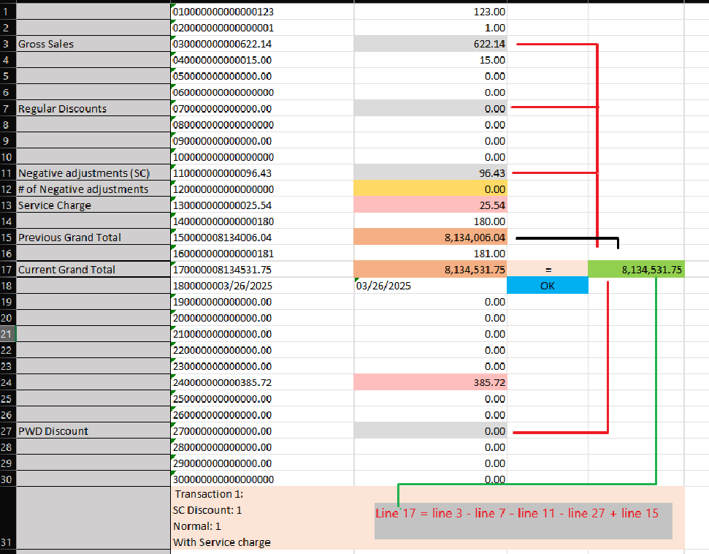

Figure 2: RLC txt file Transaction 2 (Void)

* With SC Discount

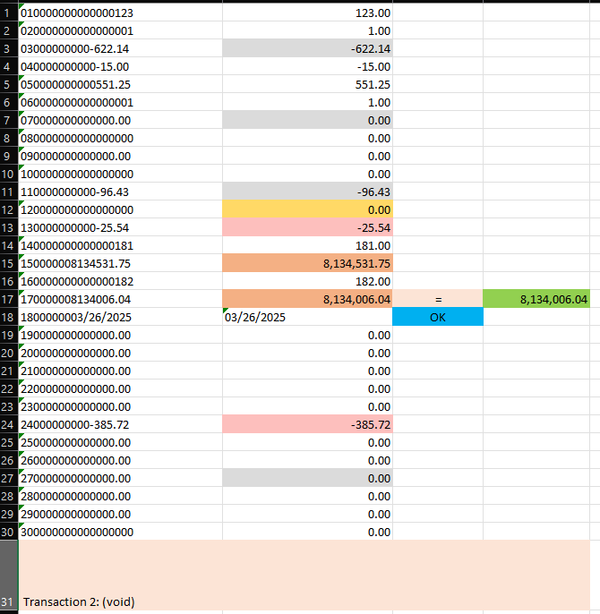

Without Service Charge Transactions (SC Discount)

Steps Taken:

* Transact:
  + Item 1 (SC discount)
  + No service charge
* Settle
* Z Read
* Send Tenant Data ( see result in figure 3 )
* Void Previous Transaction
* Z Read
* Send Tenant Data ( see result in figure 4 )

Figure 3: RLC txt File Transaction 3

* With SC Discount
* No Service Charge

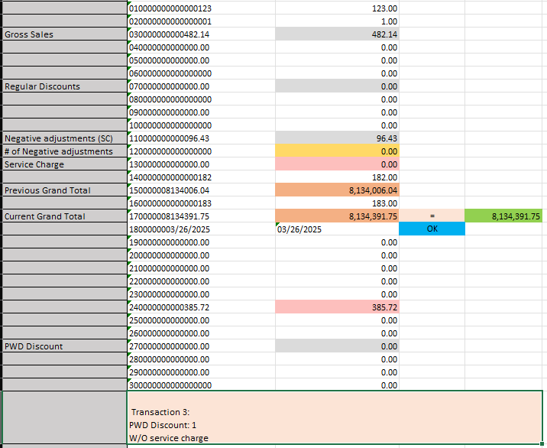

Figure 4: RLC txt File Transaction 4 (Void)

* With SC Discount
* No Service Charge

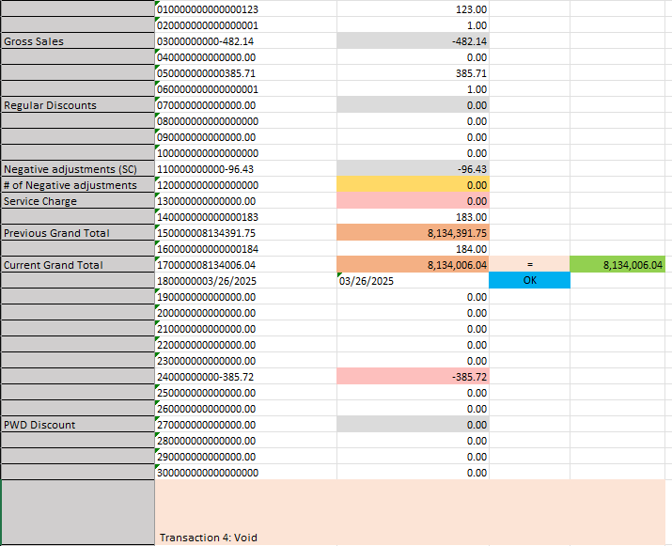

With Service Charge Transactions (Regular)

Steps Taken:

* Transact:
  + Item 1
* Settle
* Z Read
* Send Tenant Data ( see result in figure 5 )
* Void Previous Transaction
* Z Read
* Send Tenant Data ( see result in figure 6 )

Figure 5: RLC txt File Transaction 5

* Regular
* W/ Service Charge

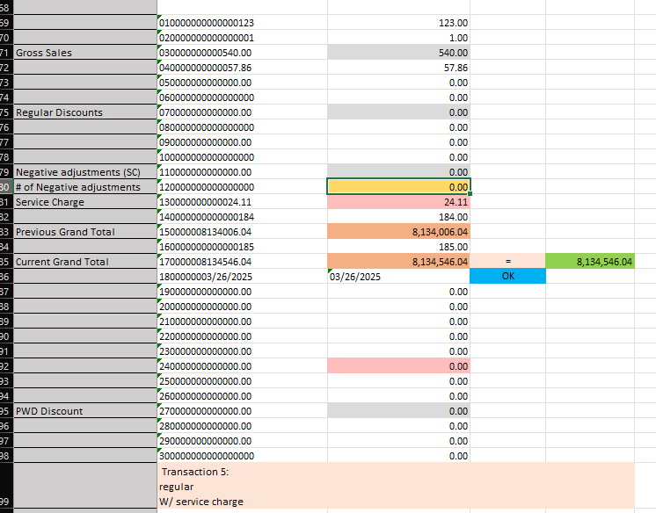

Figure 6: RLC txt File Transaction 6 (Void)

* Regular
* W/ service charge

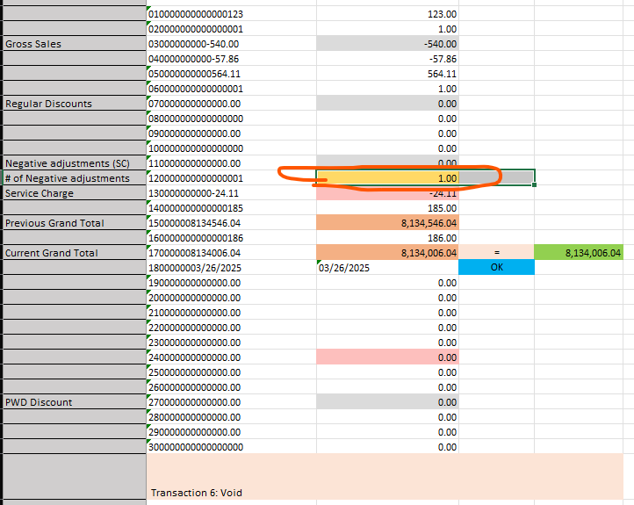

Mix Transactions (2 regulars, 1 w/ SC Discount)

Steps Taken:

* Transact 1:
  + Item 1
* Settle
* Transact 2:
  + Item 1
* Settle
* Transact 3:
  + Item 1 (w/ SC discount)
* Settle
* Z Read
* Send Tenant Data ( see result in figure 7 )
* Void Previous Transactions (all 3)
* Z Read
* Send Tenant Data ( see result in figure 8 )

Figure 7: RLC txt File Transaction 7

* w/ Service Charge
* 2 Regulars, 1 w/ SC Discount

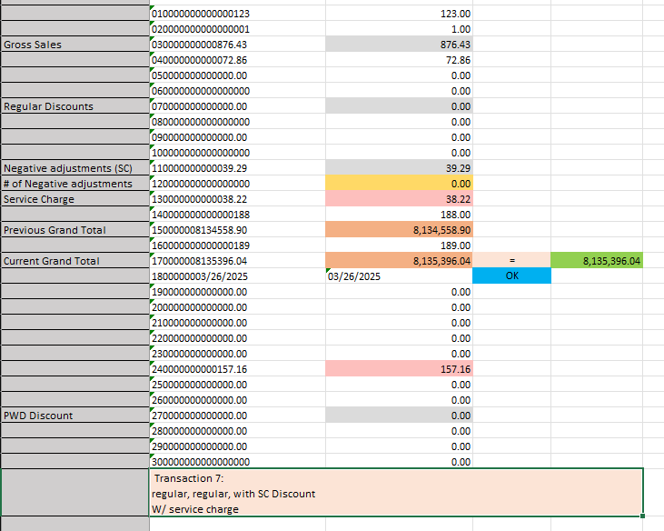

Figure 8: RLC txt File Transaction 8 (Void)

* w/ Service Charge
* 2 Regulars, 1 w/ SC Discount

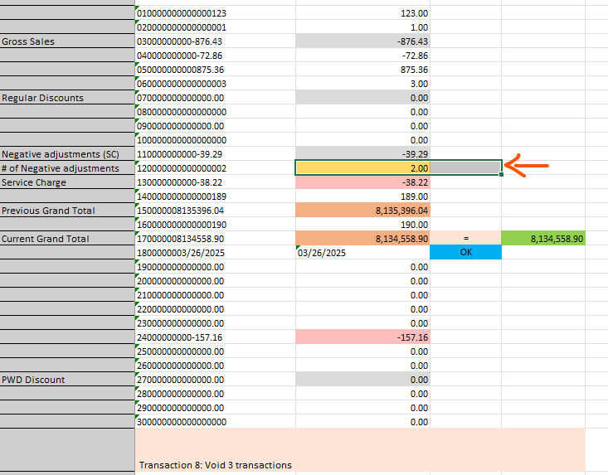

OFFLINE TERMINAL Transactions

Steps Taken:

* Transact 1:
  + Item 1
* Settle
* Transact 2:
  + Item 1
* Settle
* Transact 3:
  + Item 1 (w/ SC discount)
* Settle
* Z Read
* Send Tenant Data ( see result in figure 7 )
* Void Previous Transactions (all 3)
* Z Read
* Send Tenant Data ( see result in figure 8 )

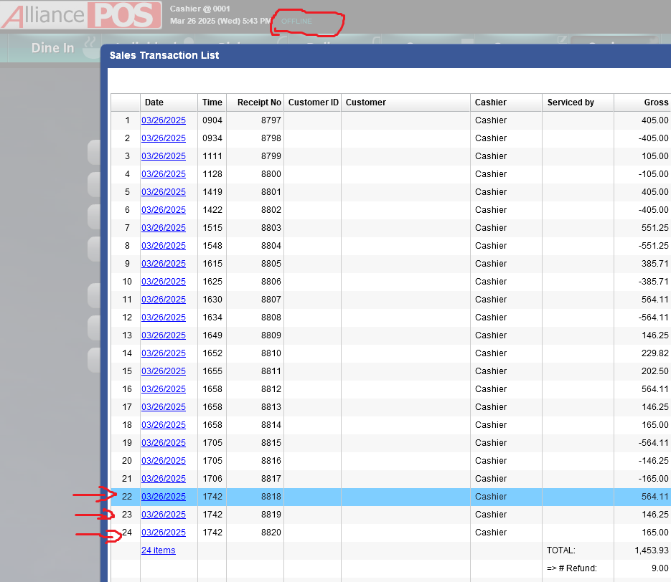

Figure 9: RLC txt File Transaction 9

* Offline Terminal
* 2 regular, 1 w/ SC discount

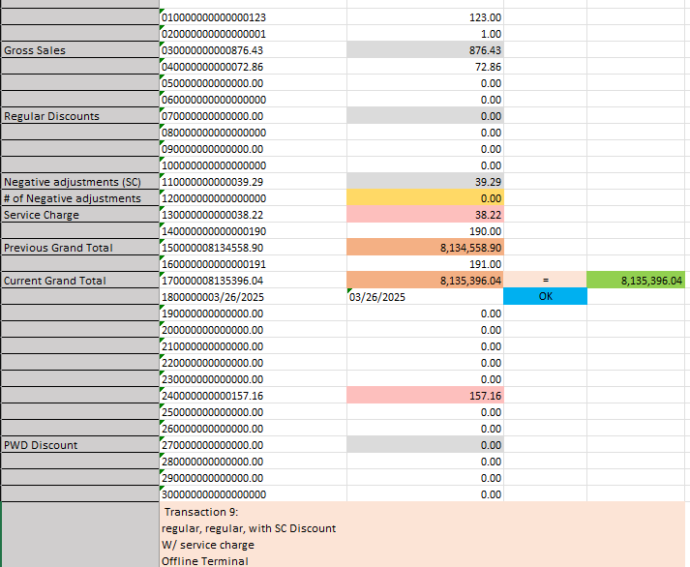

Figure 10: RLC txt File Transaction 10

* Offline Terminal
* 2 regular, 1 w/ SC discount

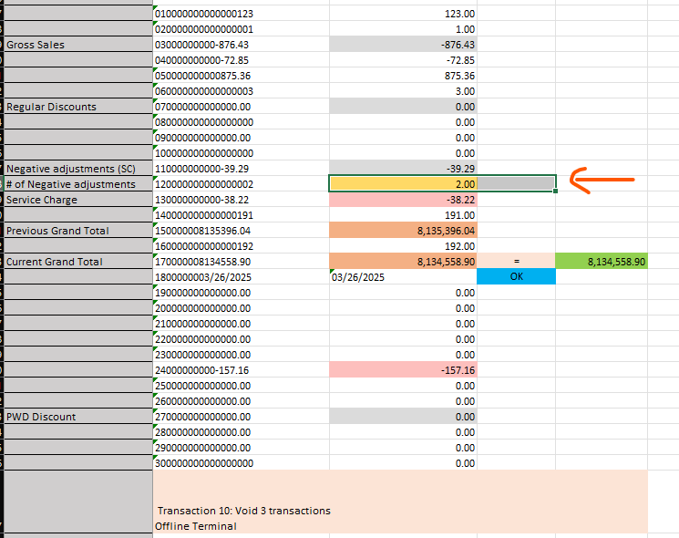

Summary

Both Online and Offline Terminals:

* Line 12 : only counts voided transactions without SC Discount
* Line 15 : removed service charge in the formula
* Line 17 : removed service charge in the formula